**Ashish_RQuiz 3**

1. Write if/else ruby statement in only one line

**Ans :** if 10==10 then puts "True" else puts "False" end

OutPut:

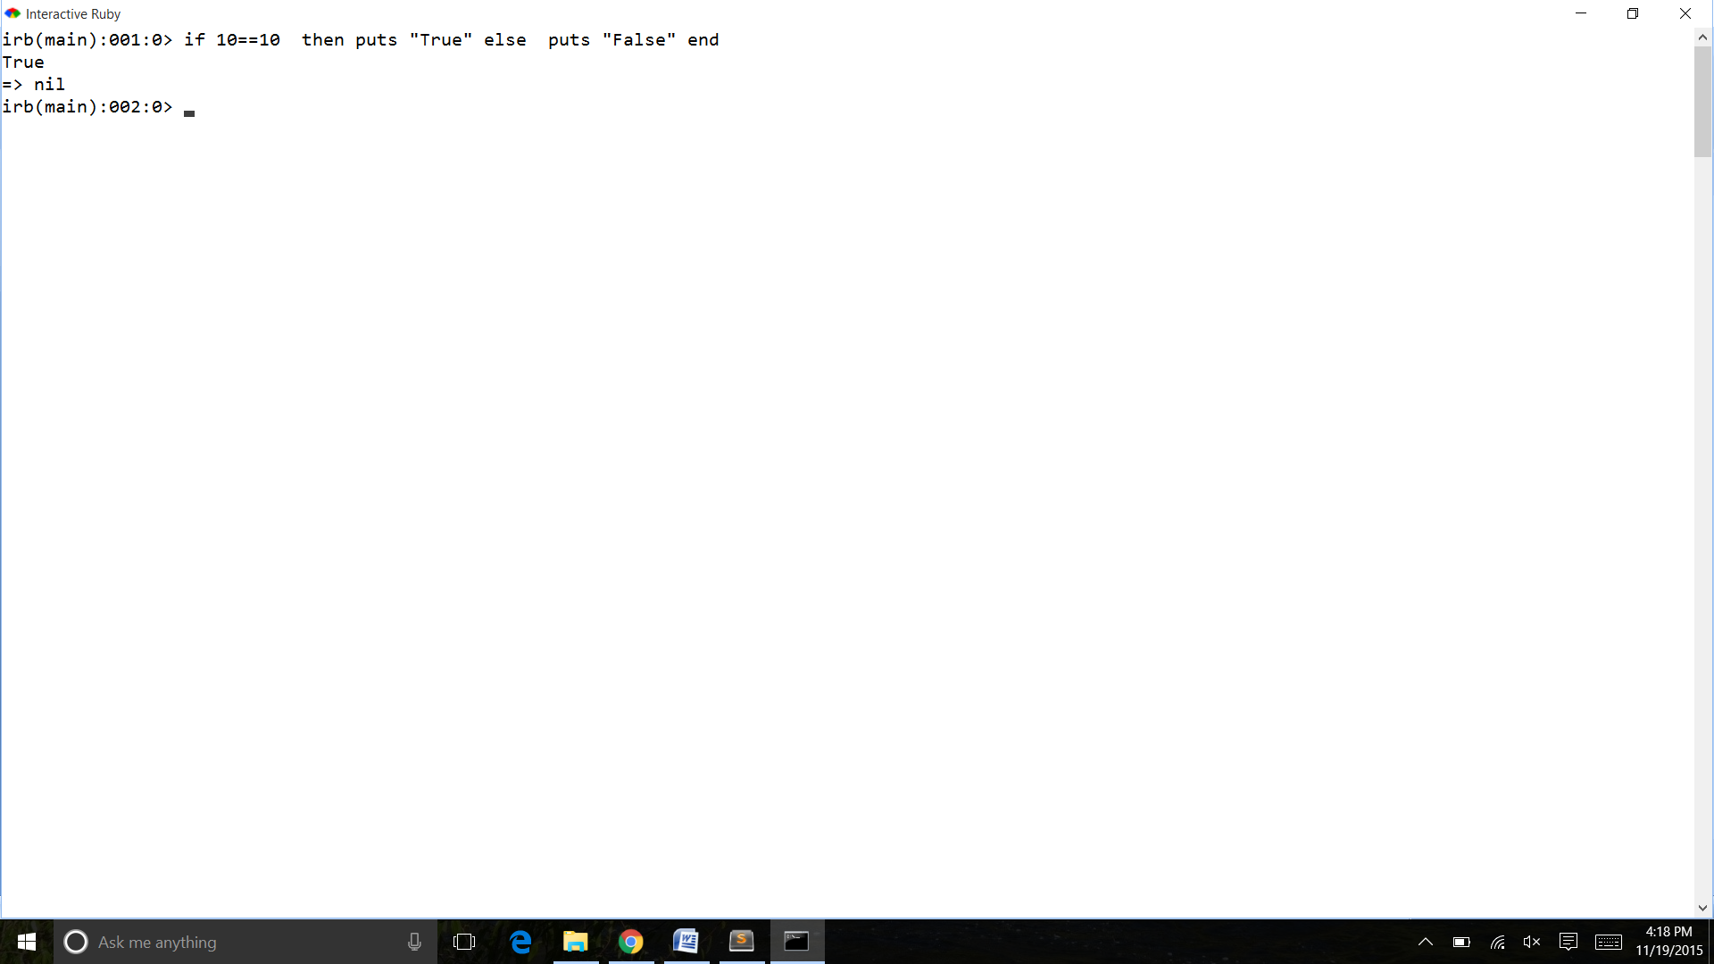

2. Ruby program that calculatesthe sum of all the numbers between 0 and 100 that are divisible by both 3 and 5?

Ans:

sum = 0

for i in 0..100

if(i%3==0)&&(i%5==0)

sum = sum+i

puts i

end

end

puts "the sum of numbers is :",sum

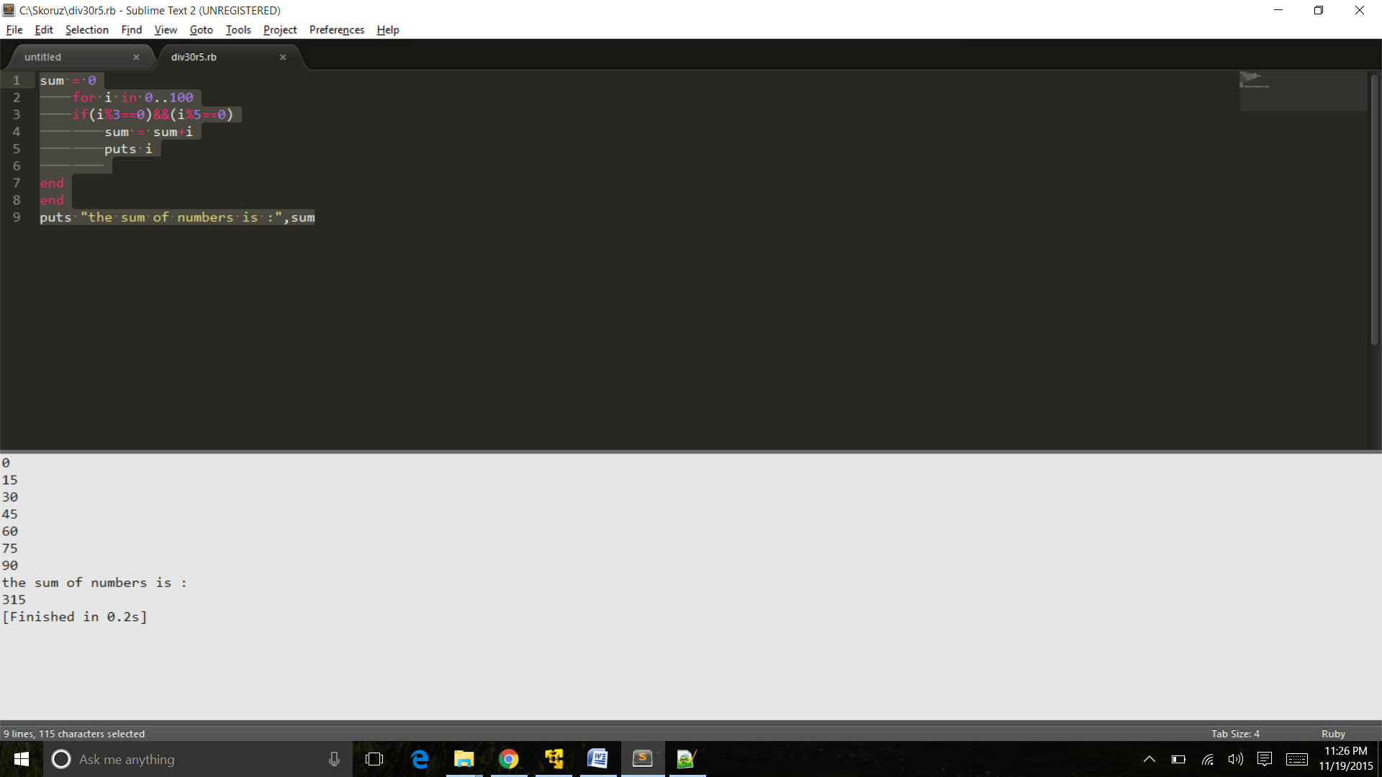

3. Write a Ruby program to convert user input to upper, lower and capital letters

Ans:

"HELLO WORLD!".downcase

"hello James!".upcase

"hello James!".capitalize

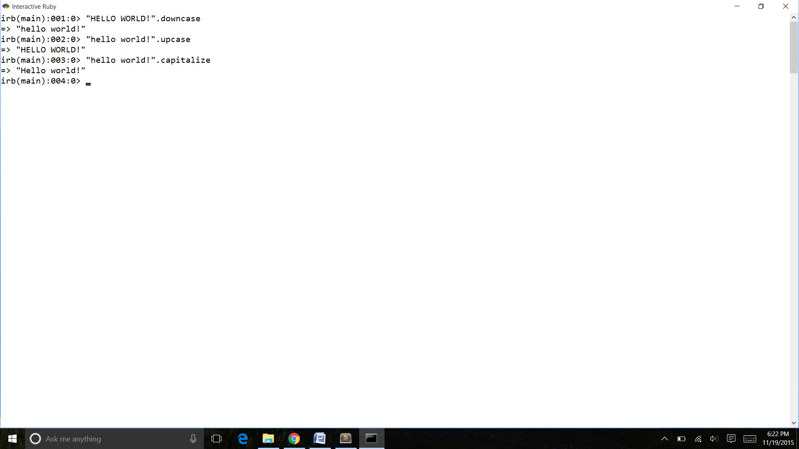

4. File Operations with Ruby

write your own ruby program that :

creates a file and writes some text into it, then closes it,

open the same file, and print all lines inside that file,

then, delete that file

Ans :-

1)

lines =["This is the first line","This is Second line","This is the third line"]

f = File.new("raymonds.txt","w")

lines.each{|line|f.puts(line)}

f.close

2)

lines = []

file = File.open("raymonds.txt","r")

while (line = file.gets)

lines << line

end

file.close

lines.each{|l| puts l}

File.delete("raymonds.txt")

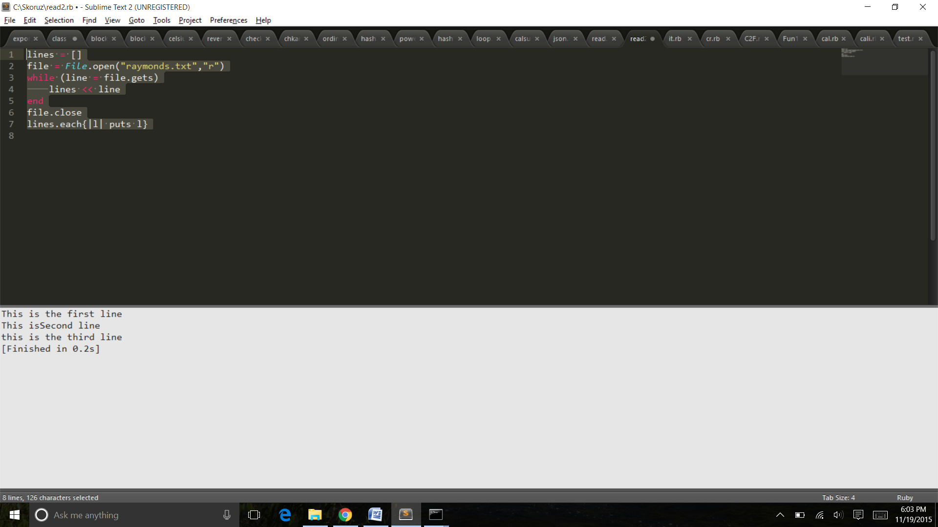

5. write your own Ruby program that converts a array to yml and loads the yml output and print array using:

load()

dump()

Ans:

require 'yaml'

names = %w[abc def hig pqrt wyz]

#Example 1: Converting an array into YAML using: dump()

yaml_example1 = YAML::dump(names)

puts yaml_example1

#Example 2: Loading YAML back into an array using: load()

array_example = YAML::load(yaml_example1)

puts array_example

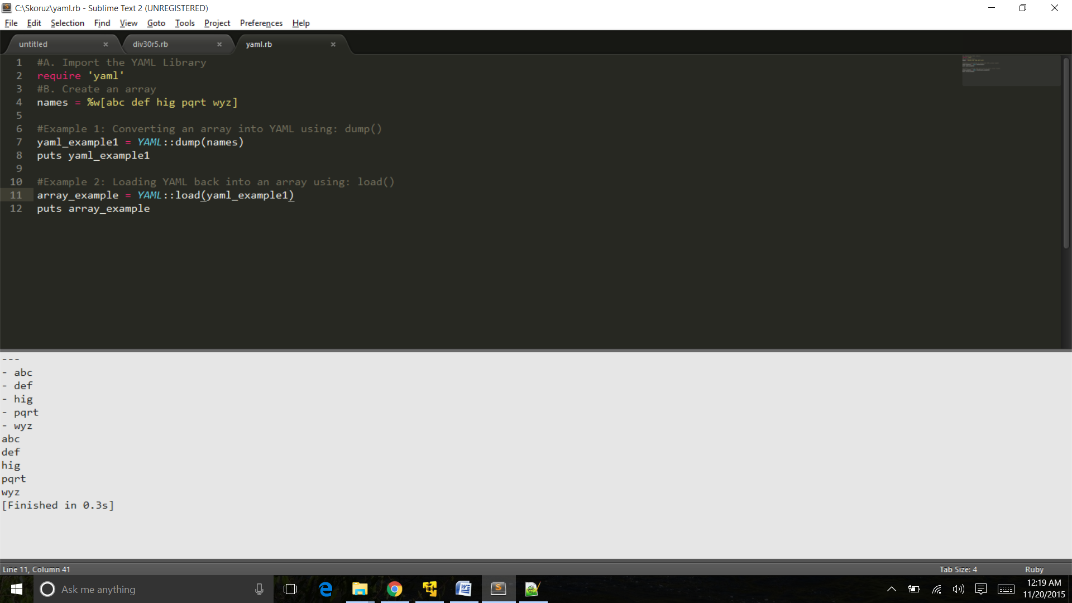

6. Write a Ruby program that converts a array into json, now parse your json looking for a specific array element

7. Write a Ruby program to generate json using  pretty

Ans :

require 'json'

my_json = { :array => [1, 2, 3, { :sample => "hash"} ], :foo => "bar" }

puts JSON.pretty_generate(my_json)

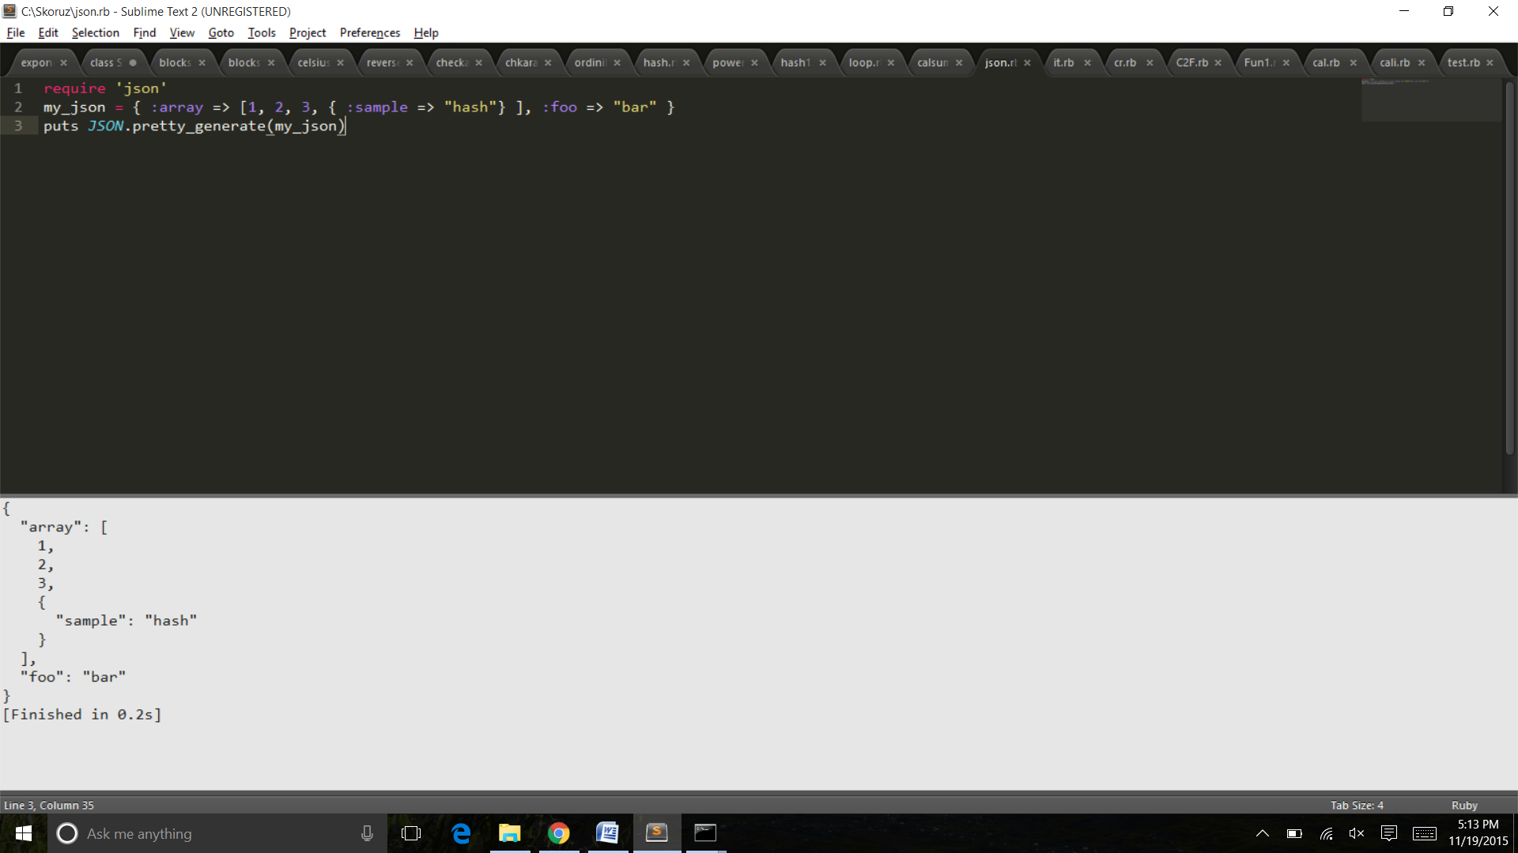

8. Write aRuby program that connects to MySQL Database in your pc and executes a select query

Ans:

#!/usr/bin/ruby

require "rubygems"

require "mysql2"

begin

con = Mysql.new 'localhost', 'username', 'password', 'testdb'

rs = con.query("SELECT * FROM emp")

n_rows = rs.num_rows

puts "There are #{n_rows} rows in the result set"

n_rows.times do

puts rs.fetch_row.join("\s")

end

rescue Mysql::Error => e

puts e.errno

puts e.error

ensure

con.close if con

end

